Game Engine 1

Jerry Järvelä / AA2890 / Portfolio

These are the Unity projects I have worked on and learned from for the course Game Engine 1.

Obstacle Course

The first project I created was a simple obstacle course which taught me how Unity handles collision on a basic level, utilizing simple blocks to accomplish this which notify the user when a collision has happened.

Using basic OnCollisionEnter with a Coroutine lets highlight the object which got hit for a certain amount of time.

Using a SerializeField I’m able to give a value to an object and have a simple if statement determine how long it will take before the objects get enabled with gravity, allowing them to fall down.

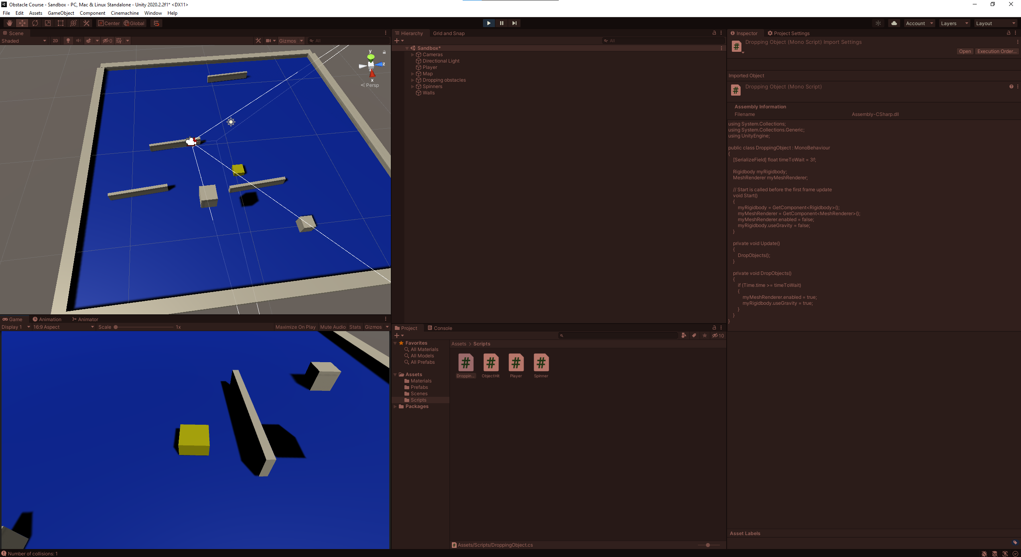

Laser Defender

Laser Defender was the second project I worked on and it became a 2d space invaders type game. It uses scriptable obejcts in unity to spawn enemies in a clean and scalable way. Using Waypoints I am able to easily determine which enemy wave will follow which path, which can make for some lucrative levels.

In this project I delved deeper into the Unity API and how it works, learned how the UI elements for Unity works on a basic level.

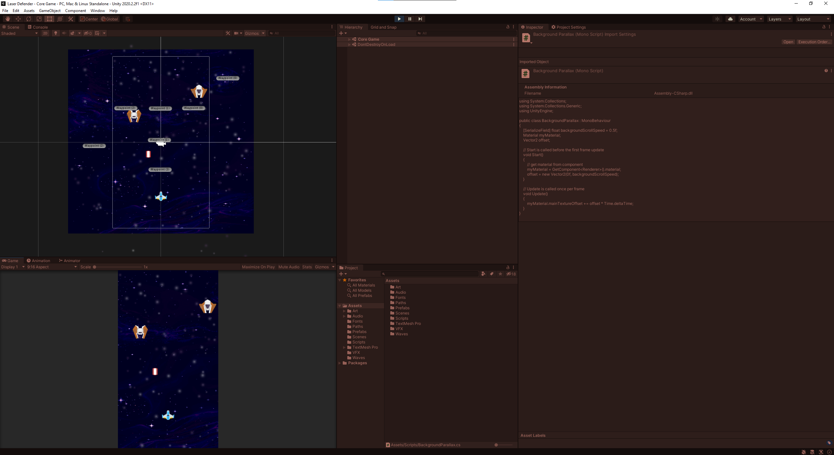

Steve In Briefs

I laid out the foundation of a 2d platformer for our group game for the GCD course called “Steve In Briefs”. I took the role of lead developer for the project and we used “SuperTiled2Unity” to create our level layouts.

<https://www.youtube.com/watch?v=uxHL4FWt3jk>

Other credits for the project: Eevi, Jesse, Gunwoo and Suat.